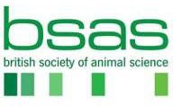**Confidential**

# **Scientific Committee - Expression of Interest Form**

**Please note:**

# This application form aims to help you demonstrate your suitability for the role of Scientific Committee Member on behalf of the British Society of Animal Science (BSAS).

Section A – Personal details

First name(s)

Last name

Contact details: Address

Email

Telephone

How did you find out about this vacancy?

Briefly tell us why you are interested in becoming a member of the BSAS Scientific Committee and what strengths, expertise and experience you would bring?

**Section B – Membership**

Are you a current member of BSAS?