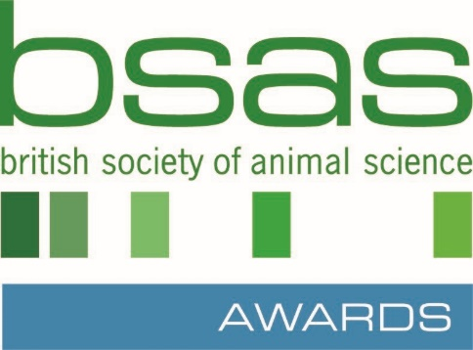

BSAS Undergraduate Thesis of the Year Award 2024

REGISTRATION OF INTEREST

PLEASE REGISTER YOUR INSTITUTION’S INTEREST IN ENTERING THIS YEARS AWARD
AS SOON AS POSSIBLE to bsas@bsas.org.uk

Name:

Job Title:

Department:
Institution:

Address:

E-Mail Address:

Tel No:
(direct line/mobile)

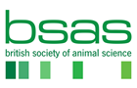ma
Email: bsas@bsas.org.uk | Web: bsas.org.uk
British Society of Animal Science SCIO | Charity No SC050710

