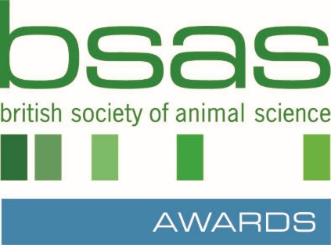

BSAS Animal Science Undergraduate Thesis of the Year Award 2024
APPLICATION FORM

Entrant 1 Name:
Entrant 1 Email:
Entrant 1 Thesis Title:
Entrant 2 Name:
Entrant 2 Email:
Entrant 2 Thesis Title:

Submitters Name:
Job Title:
Department:
Institution:
Address:
E-Mail Address:
Tel No:
(direct line/mobile)

PLEASE COMPLETE AND RETURN THIS FORM BY 31st July 2024 WITH ACCOMPANYING THESIS OR DISSERTATIONS AND ABSTRACT FOR EACH APPLICANT TO
bsas@bsas.org.uk

Email: bsas@bsas.org.uk | Web: bsas.org.uk
British Society of Animal Science SCIO | Charity No SC050710

